
Course document

Inquiry Scenario
Plan Design form

for the promotion of Sustainability Citizenship

School Details
School Name |  | Minority school of Dokos
City name (Rural/ small town/ middle town/ big city) |  | Dokos is a village situated in northern Greece 25km away from the capital Komotini
Number of pupils and teachers |  | 33 pupils, 4-6 teachers
How many students and teachers will be involved in the Plan? |  | 12 students, 1 teacher

Sustainable Contact Details:
Name | Vasiliki Psaridou
Email | psaridou@gmail.com
Contents
Inquiry Scenario 1
Plan Design form 1
for the promotion of Sustainability Citizenship 1
Sustainable Contact Details: 2
Title: 3
Short Description (Max 500 words): 3
Keywords (Up to 5): 3
Information about the Implementation 3
Language of the students: 3
Age of the students: 3
Number of Lessons – Duration (per lesson): 3
Is this activity a STEM Activity? 3
Information about the Scenario 4
Objectives (Max 100 words): 4
Materials (Max 100 words): 4
Use of School Infrastructure 4
Green competences: 4
Working with the community 5
How will the above-selected institutions help in the educational scenario? 5
Detailed activity description 5
Evaluation (if any): 6
References (if any) 6
Sustainable Contact Details: 6
Annex 6

Title:
Am I aware of Climate Change and can I protect my Nature?

Short Description (Max 500 words):
This scenario challenges students to make a difference in research and protection of the Earth. In this program, students will take on the role of climate scouts, while learning about the Earth's Environment and climate. They will mainly focus on disasters resulting from various factors (human and non-human). They will meet experts on the field of weather and climate, such as Meteorologists, Environmentalists and Foresters. They will visit a local Forest, which was burnt down the previous year, to see firsthand the reasons and the damage the fire had created. They will write an official letter to the local mayor, in order to make their proposals known, for improving the conditions and survival of the local environment.

Keywords (Up to 5):
Climate, Change, Environmental Protection, Active Citizenship

Information about the Implementation

Language of the students: Greek

Age of the students:
√9-12 ☐ 12-15 ☐ 15-18 ☐ 18+

Number of Lessons – Duration (per lesson):
Number of Lessons: 5 Duration per Lesson: 1 month

Is this activity a STEM Activity?
For which subject(s) the activity is usable, is it an interdisciplinary activity?
Science √
Physics ☐ Chemistry ☐ Biology☐ Geosciences☐ Environmental√ Other√
Technology √
Engineering ☐
Arts √
Mathematics ☐

Information about the Scenario
Curriculum and country: Primary school curriculum, skills workshops, Greece
Link of the current activity to the curriculum:
Country: Greece Class: Primary school Grade: 5th – 6th grade
Topic: Greek language, Environmental Studies - Geography, Social and Political Education, Informatics

Objectives (Max 100 words):
Description of the learning objectives
After implementing the scenario, students should be able to:
- Knowledge Level
- understand that the Earth's environment is a complex and changing system
- learn from scientists and Earth observation experts through videos, visits and other opportunities held nationally.
- Skill Level
This specific program attempts to:
- promote the teaching and learning of STEAM competencies and skills, including scientific methodology, data collection, visualization and analysis
- Level of Attitudes of the students:
- they will learn the importance of respecting our environment.
- they will channel their energy into the protection of their directly dependent environment
- will propose changes in attitude by writing an official letter to the local Mayor

Materials (Max 100 words):
Which resources and materials (software, hardware) are needed?
School Infrastructure | School Materials
- Hellenic National Meteorological Services http://www.emy.gr/emy/el/  - Geography - Weather and climate - 5th-6th Primary Grade 152  https://youtu.be/I9VsY6VzZS4?feature=shared  Differences between weather and climate (Interactive Video)  https://www.youtube.com/watch?v=dSOgEbYnNz8  - What is Climate Change? https://www.youtube.com/watch?v=QlQ-MEZgRGY  - Which outcome do you feel has the most impact on your life?  https://answergarden.ch/4128180  - Climate Change: https://wakelet.com/wake/2sYNZw0gjAgq1D-nnUam1  - Climate Change: https://view.genially.com/6540d4801ab1c100114abbf5/interactive-content-climate-change  - How can I help? https://padlet.com/psaridou/padlet-ci36kv3g12ka  - Climate Change – A game: https://scratch.mit.edu/projects/913567453  - Natural Environment and Climate Change Agency https://necca.gov.gr/mdpp/m-d-ethnikon-parkon-delta-evrou-dadias-kai-prostatevomenon-periochon-anatolikis-thrakis/#Draseis  - • Social and Political Education 5th grade, Primary book : http://ebooks.edu.gr/ebooks/v/html/8547/2346/Koinoniki-kai-Politiki-Agogi_E-Dimotikou_html-apli/indexD_2.html  - The parts of the letter: https://slideplayer.gr/slide/2915525/ | - Class computers or tablets  - Internet connection  - Projector  - A4 papers

Use of School Infrastructure
How are school facilities and equipment used in your educational scenario?
School Infrastructure | School Materials
Due to the use of the internet, children will have to search for material (videos, articles, etc.) and record them in a new online tool. For this reason, the exploratory method also makes its presence felt in the program.  A projector is needed in order to held online meetings with WWF and other experts. A microphone should be present too, so as students will ask their questions directly to the experts, in order to have a dialogue  The dissemination of the program will be done through the school's website, but at the same time the local Mayor and Municipal Council will be approached, so that the results become more widely known, mainly to give the possibility of an experiential approach to the students through the presentation of their opinions to a Municipal Council. | - Class computers or tablets  - Internet connection  - Microphone  - Projector
Student evaluation will be done through gamification. Students are asked to create and answer questions in groups through games, with the aim that the program does not take the form of an exam, like other school subjects.

Green competences:
Which green competences are covered by the activity?

Embodying Sustainable Values | Valuing Sustainability | X | Supporting Fairness | ☐ | Promoting Nature | X
Embracing Complexity in Sustainability | Systems Thinking | X | Critical Thinking | X | Problem Framing | X
Envisioning Sustainable Futures | Futures Literacy | ☐ | Adaptability | X | Exploratory Thinking | X
Acting for Sustainability | Political Agency | X | Collective Action | X | Individual Initiative | ☐
The definition of the following terms can be found in GreenComp that is translated in all European Union languages.

Working with the community
Which external actors will be involved within the framework of the training scenario?
Organisation Type | Organisation Name
NGOs (Non-Governmental Organisations) | WWF Hellas
PTA (Parent-Teacher Association)
Local business
Other (please explain) | Local Mayor, HNMS (Hellenic National Meteorological Service), Natural Environment and Climate Change Agency

How will the above-selected institutions help in the educational scenario?
HNMS (Hellenic National Meteorological Service) will be the first step for the students to understand the differences between Climate and Weather. Usually, these concepts are difficult to be distinguished by students at this age (11-12 years old). With the Meteorologist’s help and examples given specifically for our region, students will have a better awareness on these two meanings.
WWF Hellas will help students understand the meanings of concepts like Greenhouse Effect, Fires, Floods, Melting Ice. Those experts will give us some examples that will give the students the opportunity to compare with their own everyday life.
Forest of Dadia is part of the Natural Environment and Climate Change Agency (N.E.C.C.A.) with the aim of implementing a modernized and contemporary system of governance for Protected Areas. Dadia’s Forest, which is nearby, suffered huge fires the previous year due to climate change. A visit to the burnt areas with a forester guidance will be done together with specialists answering to questions of the students who will be present to see the effects of Climate change to their neighborhood.
Local Mayor will have a huge impact to this specific project. The teacher has taken care to obtain the appropriate permits and to visit the local Town Hall with his/her students. At a specified meeting of the Municipal Council, the children's letter is presented by the students themselves, in order to motivate the Municipal Councillors to take more measures to suppress but above all to protect the local environment

Detailed activity description
Fill in the table below according to the hours of the training activity and its content (fill in the table with the subjects contained in your training scenario).
The educational scenario should follow the 5E didactic model of inquiry-based learning.
Number and name of courses | Course content | Teaching hours
Lesson 1: Climate and Weather differences | The emphasis is on engaging students to think and discuss the Earth's environment and climate and guiding them to identify a local environmental problem they would like to investigate.  Students are asked questions about what they know about our environment and climate. If they know the difference between weather and climate. If they know about the problem of global warming and its effects and if this problem has affected our area.  We will have an interview with a Meteorologist from Hellenic National Meteorological Service. He/She will inform us about what Climate is and what Weather is, how can identify what is Climate and what is Weather and gives us examples of past and recent years regarding our own region (East Macedonia and Thrace). Students will ask questions and feedback will be given to them.  Then, they will watch a documentary by the Ministry of Education on "Geography - Weather and climate - 5th-6th grade 152" and will play in groups with the video "Differences in weather and climate (Interactive Video) by Miltiadis Kotziampasis ".  Internet research: What is global warming? Creating a concept map with the tool Mindomo (indicative fig.1, the Mindomo platform creates a powerful environment where one can easily collaborate with others by sharing ideas and collaborating on mind maps in real time) for its results.  Which of these results do you think has an impact on our region? The teacher shares the link (indicatively using the Answergarden tool fig.2, an online tool for collecting ideas of our students) and the students will have one week to answer the question, the data of which is used as input in the next lesson. (We facilitate those students who cannot use the link at home, by giving their answer on the classroom computer). | 1 month
Lesson 2: Learn about Climate Change | To learn more about climate change, students should find some videos and useful materials on the Internet about: a) what is climate change( for example What is Climate Change?) b) what are the effects of climate change (What are the effects of Climate Change?) c) what can be done to solve the problem (Climate Change : What can we do?). (The above videos are in English. However, they can be easily watched and understood by all students, due to the fact that they are short and have meaningful images)  Then, the students are divided into three groups. Each group will undertake an individual topic from the above related to Climate Change and find useful material on the internet (videos, articles, etc.). In order for the whole process to take place in a controlled area, the IT room is recommended where the teacher can request the assistance of the IT teacher.  Each group looks for the information and videos on the internet and together with the teacher it is checked to meet all the criteria (within the topic and material suitable for children). The teacher collects the material of all the groups and creates a presentation. Suggested tool Wakelet (indicative fig.3, Wakelet is a free platform for collecting, organizing and sharing digital content) and indicative example: Climate Change  The final result is presented to the plenary of the class. Discussions take place around each video or article separately; questions and concerns are resolved and each child is given the opportunity to express himself on what he has watched. | 1 month
Lesson 3: Working in groups | The third teaching part can be done entirely in the IT class. We introduce the idea to the plenary, namely the creation of an escape room using technology.  To create the escape room we will use the Genial.ly tool (Genially is a digital online tool that allows the creation of interactive material using images, presentations, infographics, digital cards). Before the creation of the Escape Room, students will meet online (and face to face if possible) with some Climate professionals such as those from WWF. (WWF Hellas can help us understand the meanings behind those words). The students will be divided into four new groups. Each group will take on a sub-topic (Greenhouse Effect, Fires, Floods, Melting Ice) and are asked to create two questions using pictures and words. Each group will not inform the others about the questions and the correct answers, so that there is a strong interest in the class when using the game. The teacher is an assistant throughout the creation of the game and is also the final controller of the material.  The presentation and playing of the game will take place in the plenary session of the class. Indicatively, we created this game (indicatively fig.4) with my students. | 1 month
Lesson 4: playing and Learning | The teacher opens a Padlet (the Padlet tool works as a collaborative digital bulletin board, where each user can upload his/her point of view through image, video and other tools). Each student individually makes his/her own post about what can be done to avoid or mitigate the many effects of Climate Change in our area. Here (indicative fig. 5) you can see how the students of my school approached the subject. As some students made their posts, others collaborated to create a poster using another digital tool Canva (Canva is a digital tool for designing graphics, presentations, posters and more).  The teacher opens the Scratch online coding and programming tool. Together with his and her students they design a question-and-answer game around what they have seen so far about Climate Change. Together with my students we created the following game (indicative fig. 6)  The game is played in the classroom by the entire group of children | 1 month
Lesson 5: Visits to Forest of Dadia and to the mayor | In the context of environmental education, they will pay a visit in the area of the Dadia’s Forest in order to raise environmental awareness among our students. Dadia’s Forest belongs to Natural Environment and Climate Change Agency and has many educational programs for students for all ages.  The environmental actions of the Management Unit are also supported by the existence of the Information Center which has been operating in Dadia for 25 years now. Its role is to welcome the visitor and help him/her observe and interpret nature, while at the same time informing him/her about the National Park and its ecological, cultural and other values. At the Information Center, which operates daily, the visitor has the opportunity to visit the renovated exhibition with photographic and informative material and to watch an informative documentary about the National Park. Then there is the possibility of a tour by specialized staff at the observatory of vultures and birds of prey or a tour of marked paths in the forest. Students will see pictures and videos of the Forest before and after the fire and make comparisons. This will be a lifetime experience for all of them.  Back to the class, a dialogue will begin about the situation they saw during the visit. A question that will arise is “What can we do about it?”.  The teacher invites the students to refer to Section D and specifically to chapter 2 of the Social and Political Education book of the 5th grade, in which reference is made to the role of the municipal authority, its obligations and those who can participate in a Municipal Council.  They will watch a video on "The textual genre of the letter" by Mrs. Skevi Stylianou - Hadjianastasi (indicative fig. 7). Then they are divided into three groups. Each group writes their own letter to the local Mayor and City Council. The teacher collects the material, the letters are read to the whole class without mentioning which group each letter belongs to, and material is selected from each group so that the final letter contains elements from all groups.  The teacher has taken care to obtain the appropriate permits and to visit the local City Hall with his/her students. At a specified meeting of the Municipal Council, the children's letter is presented by the students themselves, in order to motivate the Municipal Councilors to take more measures to suppress but mainly to protect the local environment. | 1 month

Evaluation (if any):
Please write how students are going to be evaluated
Student evaluation will be done through gamification. Students are asked to create and answer questions in groups through games, with the aim that the program does not take the form of an exam, like other school subjects

References (if any)

Sustainable Contact Details:
Name
Email

Annex
Feel free to add any more information and material you have, indicatively photos from the activity, constructions needed or any handbook that may be available online.
Fig.1 Creating a Conceptual Map for global warming and its effects
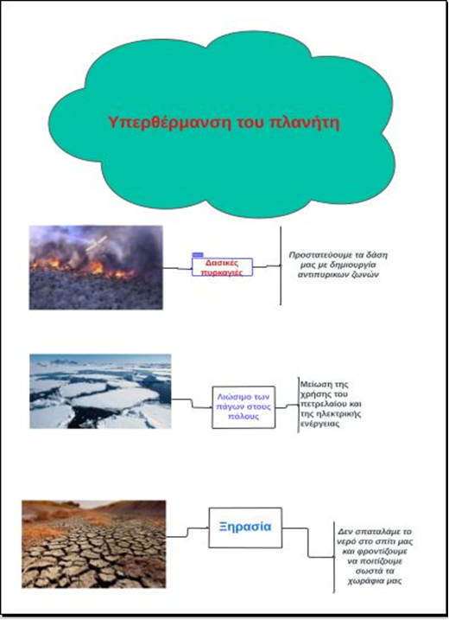

Fig. 2 Answergarden tool for creating a poll
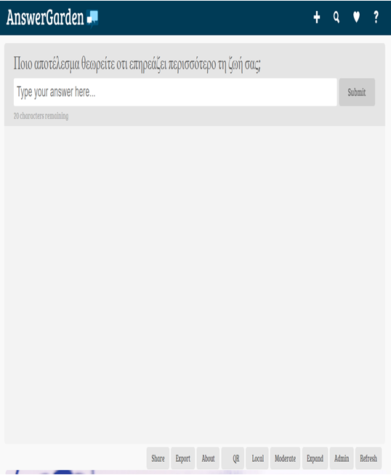

Fig. 3 Wakelet tool for creating digital material
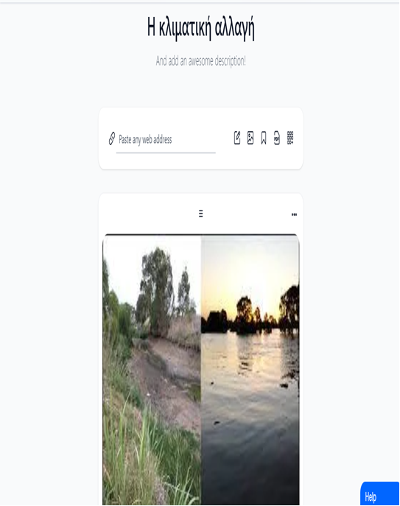

Fig. 4 The Genially tool for creating a digital escape room
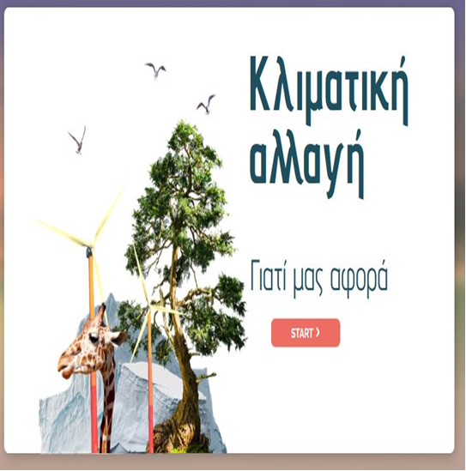

Fig. 5 The tool for posting students' opinions

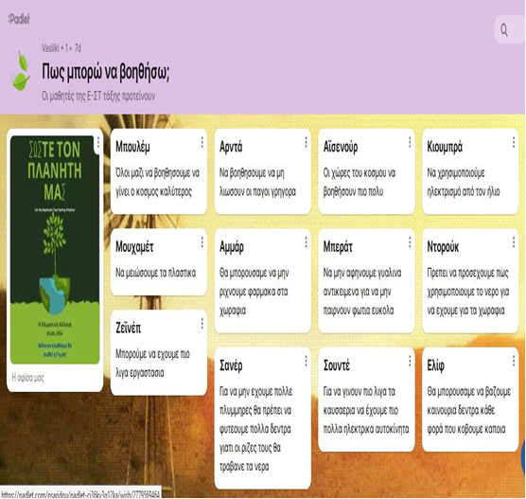

Fig. 6 The Scratch coding-programming tool

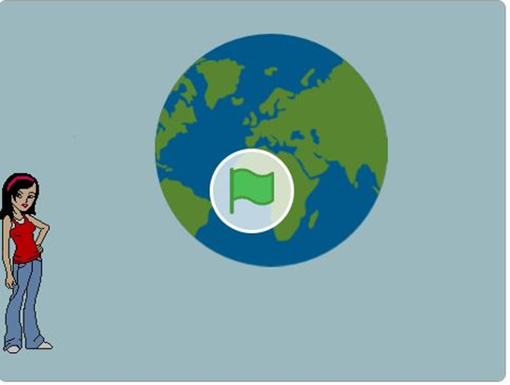

Fig. 7 The textual type of the letter Skevi Stylianou – Hadjianastasi
