
Course document

Cultivating Collective Teacher Efficacy

Green Action

Plan Design form


for the promotion of Sustainability Citizenship
Funded by the European Union. Views and opinions expressed are however those of the author(s) only and do not necessarily reflect those of the European Union or European Education and Culture Executive Agency (EACEA). Neither the European Union nor the granting authority can be held responsible for them.

Schooldetails

School Details
School Name
School Head Name
School Location
Type of place (Rural/ small town/ middle town/ big city)
Number of pupils and teachers
How many students and teachers will be involved in the Plan?

Insight, where are we now?
How does your school set up broad and inclusive consultation processes, to build trust and enhance support for changes?

How does your school consider regional or local partnerships to stimulate school development or support the implementation of specific changes?

Does your school do environmental actions regularly (e.g. tree planting; nature excursions; etc.)? If so, specify.

Does your school effectively engage parents? Elaborate.

(How) does your school create partnerships between schools and higher education institutions, focused on research, creating collaboration between theory and practice

(How) does your school promote sustainability citizenship?

Does your school encourage and support collaboration among staff for teaching (e.g. team teaching, sharing of teaching resources) and staff learning? Elaborate.

Does your school consider cross-school networks and digital platforms to support (a culture of) collaboration in the teaching profession? If so, how?

Designing the Green Action Plan
Necessity – Purpose of your action plan

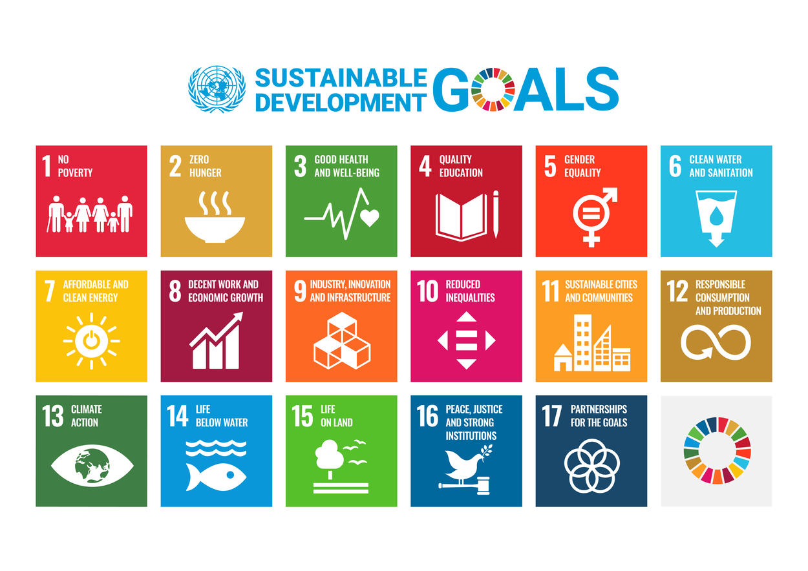

Goals (relevance to the 17 Sustainable Development Goals)

Pedagogical
Social

Environmental
….
Actions & Implementation Timetable

Distribution of responsibilities in the school community

Resources – Instruments – Research tools

Collaboration with non‐formal and informal education providers, enterprises and civil society enhanced.

Success criteria of the Action

Evaluation procedures of the Action

Dissemination, promotion, and publication of results

My own remarks

Remarks:

